

Project Everglades

**Design Document**

v1.1 | August, 2019

**Cubic | Intific**

10814 Jollyville Rd.

Building 4, Suite 350

Austin, TX 78759-5630

CONTACT INFO

**Dan Magaha**

Director of Product Development

+1 512-776—8246

dan.magaha@cubic.com

Everglades Phase 2 – Implementation Plan – SOW A – Item 2.2 a

**About Everglades**

everglades is a fully featured Ai/ML competition framework designed around a strategy game.

## GAME RULES

Everglades is a synchronous, turn-based 1v1 competitive strategy game designed to be “played” by AI players. The primary objective is to capture the opponent’s base, and the secondary objectives are capturing nodes and eliminating enemy opponents.

AI players move their units, represented in the game as one of three drone classes, around the map and attempt to capture territories, destroy opponents, and learn more about the environment and enemy positions.

The game map is made up of a series of connected nodes. Each node has a specified set of connections to other nodes. Players can move units from one node to

another so long as there is a valid connection between the two. The time to capture a node, the distance between nodes, and the arrangement of nodes and connections are all configurable.

A player’s team is composed of 100 units organized into 12 groups. The player directs groups to move between nodes with the purpose of capturing the opponent’s base. Units cannot be separated from their group or controlled individually.

The player is allowed to move up to 7 groups each turn; at least 5 groups must remain idle each turn. The server waits for both players to make their moves. Once the moves are received the game reconciles any combat and advances to the next turn.

## UNIT CLASSES

There are three classes of units: Controller, Tank, and Striker. Each class has a unique advantage.

|  |  |  |  |  |
| --- | --- | --- | --- | --- |
|  | Movement | Armor | Damage | Capture Speed |
| STRIKER | **+50%** | **-50%** | **+50%** | *base* |
| CONTROLLER | *base* | *base* | *base* | **+50%** |
| TANK | *base* | **+50%** | *base* | *base* |

Figure 1: unit class attributes

The Controller captures nodes faster, making it well-suited for capturing uncontested nodes. The Tank class has extra armor, making it a better choice for defending. The Striker has increased speed and does more damage, making it more effective at attacking enemy units, but it is also significantly lighter and susceptible to damage as a result.

Each AI player begins with 12 groups of units; eleven groups of 8 units and one group of 12, for a total of 100 units per player.

|  |  |  |  |  |
| --- | --- | --- | --- | --- |
| Group | Loadout |  | Group | Loadout |
| Group A | 8 Strikers |  | Group G | 8 Strikers |
| Group B | 8 Controllers |  | Group H | 8 Controllers |
| Group C | 8 Tanks |  | Group I | 8 Tanks |
| Group D | 8 Strikers |  | Group J | 8 Strikers |
| Group E | 8 Controllers |  | Group K | 8 Controllers |
| Group F | 8 Tanks |  | Group L | 12 Tanks |

Figure 2: Starting unit group loadout

## MOVEMENT, THE MAP AND ACTIONS

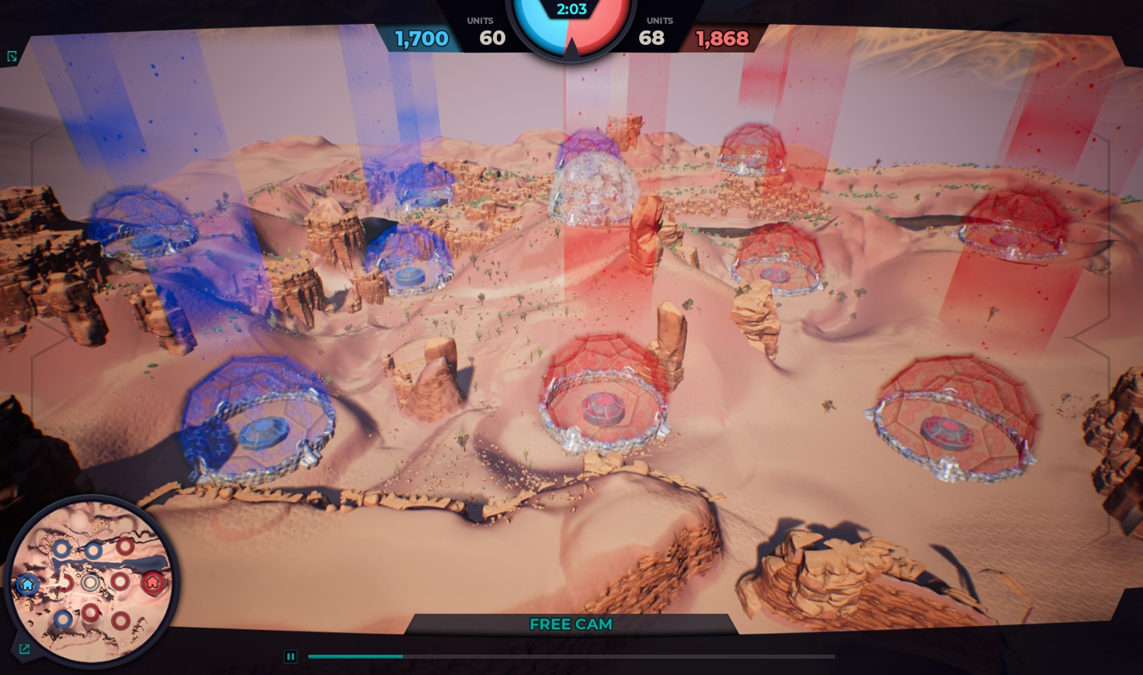

The sole tactical command AI players can use to play the game is “move.” All other strategic game functions (including engaging in combat and capturing nodes) are triggered automatically when conditions are met. These conditions are explained below.

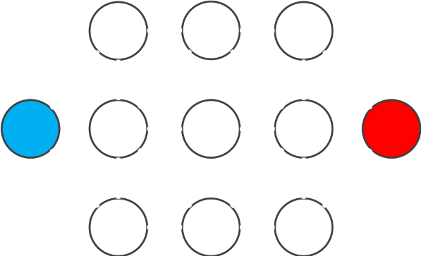Units move between adjacent nodes via connections. Units can travel through connection and do not need to have captured a node to access its connections. Every connection takes time to traverse based on its distance, and ***combat never occurs in node connections***; if opposing units enter from opposite sides of a connection at the same time, they will simply pass each other.

Figure 3: Conceptual game board. Nodes are circles; player bases are colored blue and red. Connections are lines.

Because of “FOG OF WAR”, players cannot see what is happening in a node unless they have captured that node or have active units in that area.

### SPECIAL NODE BONUSES

Some nodes provide special bonuses to the player that occupies them:

* **FORTRESSES** grant an additional defense bonus to any allied units in the area during combat.
* **WATCHTOWERS** extend a player’s scouting range to adjacent nodes even if those nodes are under enemy control.

### CAPTURING NODES

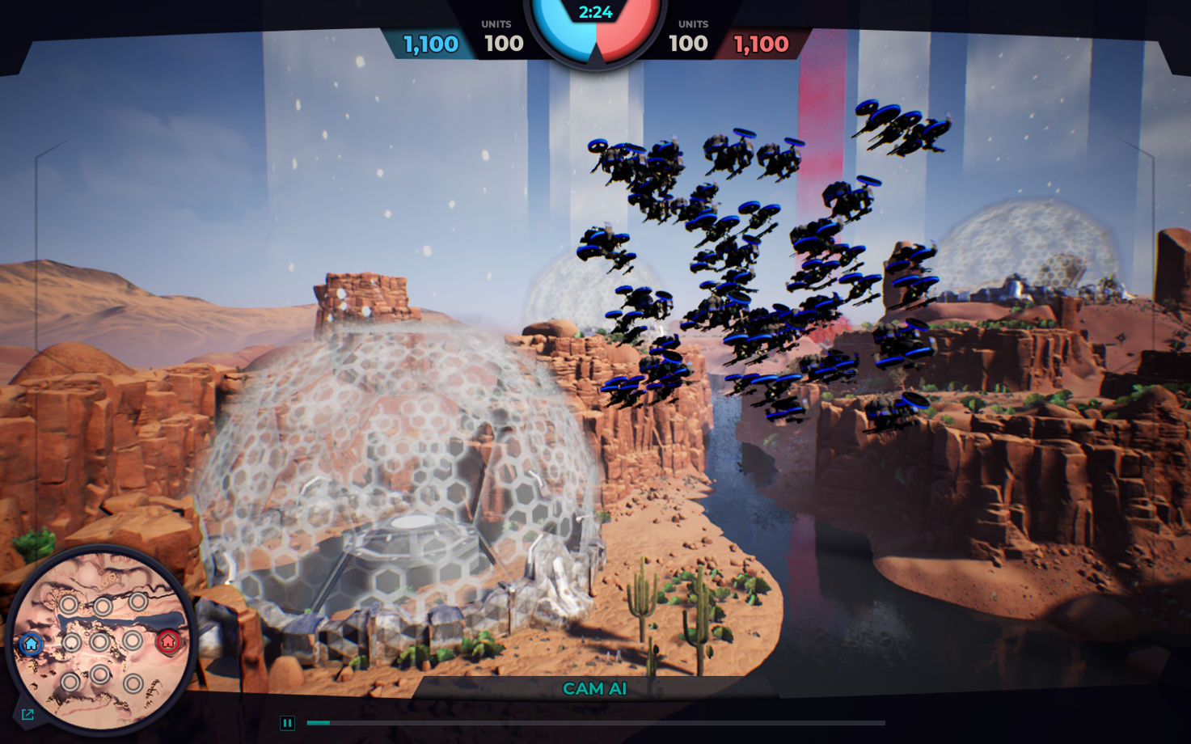

When a unit or group occupies an uncontrolled node (including after a successful attack of a previously defended node) it will automatically start to claim that node for its team.

The time it takes to capture a node is affected by a number of variables including the node’s “control points” and the highest node capture speed in the group that is capturing. Base nodes default to 500 control points and all others default to 100 control points.

***If at any time an attempted node capture is interrupted by combat, the node is considered contested and the capture timer will restart once combat resolves.***

If a team arrives at a node controlled by the other team but not actively defended, they will begin to retake the node. The node must return to neutral to be retaken. Without unit bonuses, it takes 3 turns to return a node to neutral. If the node becomes contested in that time, the timer will reset. Once the node is neutral, the timer starts for claiming the node, and follows the rules above if contested.

### COMBAT

Combat occurs automatically when opposing units occupy the same node and is resolved immediately.

Each unit class has different attack power and armor. For example, Tank units have increased armor while Strikers have increased attack power.

If combat occurs on a controlled node, the team controlling that node gains a defense modifier. A node can provide 1x, 1.25x, or 1.5x protection. This defense modifier will affect the direct damage applied by the opposing team. Base nodes have 1x protection, a node connected to either base has 1.5x protection, and all other nodes have 1.25x protection. Base nodes have 500 capture points while all other nodes have 100.

For example, if a Controller fires on a Striker in a node with 1.5x protection controlled by the Striker, the Controller will deal half its normal damage.

### 

### DESTROYED UNITS

A damaged unit does not regenerate lost health and a destroyed unit does not respawn. Once all units of a group are destroyed the group can no longer be controlled.

## WINNING THE GAME

The game ends when one team captures the other team’s base node, the turn limit (150) is reached, or if both teams are completely eliminated. **The game does not end if one team’s units are completely eliminated; the remaining team must still capture the opponent’s base to end the game.**

## RUNNING A MATCH

When you boot up the client app, you can choose to **connect to a server** or **load an existing telemetry file**. When connecting to a server, the client will launch a server in the background.

Next, you will select the two AI scripts that will participate in the match, and then click Start.

When the server starts, both AI’s will connect and send a “Ready” message. Once both AI’s are ready, the match will begin and be resolved. The client will immediately go into telemetry playback mode.

### LOADING AND VIEWING TELEMETRY

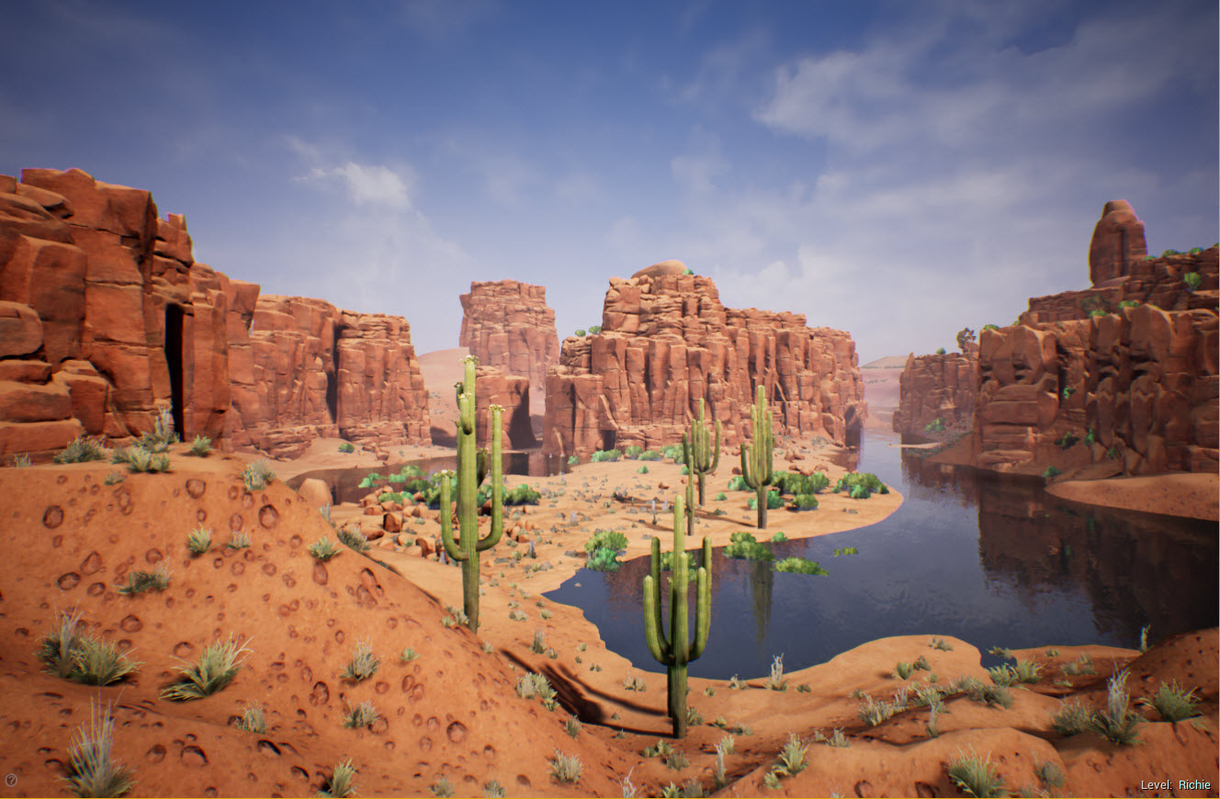

Loading existing telemetry allows you to run previous matches for playback without running a server. You will simply select an existing match telemetry file, and the match level will load. Once loading is complete, the match will be played in a cinematic “Esports” presentation mode.

You have free-roaming camera controls in this mode. The “WASD” keys controls lateral camera movement, while “Q” and “E” keys move up and down, respectively.

At the bottom of the screen is the match timeline and the “Play” button at the bottom. Clicking “Play” will begin playback (and can be toggled as a pause button once playback has started). The timeline can be scrubbed back and forth. To the right of the timeline, there is an Exit Mission button that will simply close the application at any time.

On the left side of the screen, there is a list of team groups. Initially, each team will have one group, but as orders are executed, more groups will appear. Double clicking on a group will focus the camera on that group’s movement as a Chase Camera.

Each Node is represented in a section below the groups that show the capture state of the Nodes. Double-clicking a node jumps to a fixed camera view of that node. At any time, pressing a “WASD” key, “Q” or “E” will return to Free Cam mode.

In the top center of the screen, zone control and unit status for each side is shown. There is also a timer that counts the time since the beginning of the match.